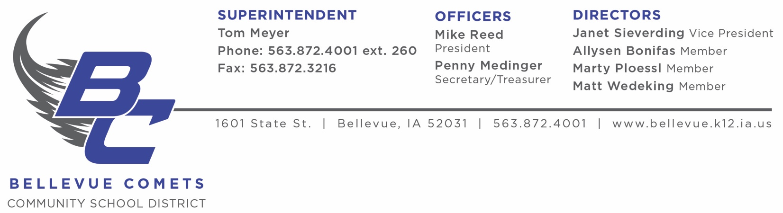

NOTICE OF INITIAL PUBLIC MEETINGS

Initial Public Bargaining Sessions between the
Bellevue Education Association
and the representatives of the
Bellevue Community School District Board of Education

Thursday, April 13, 2022
4:00 PM
Bellevue School Board Conference Room

Bellevue School Board to present initial board proposal

All other negotiations meetings are closed sessions,
as outlined in Iowa Code 20.9(3) and 20.17(3).

TM/rr
March 28 2023

