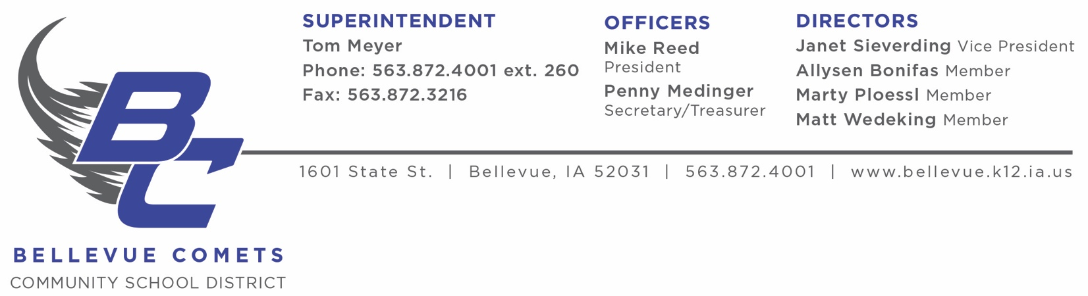

NOTICE OF INITIAL PUBLIC MEETINGS

Initial Public Bargaining Session between the
Bellevue Community School District Board of Education
and the representatives of the
Bellevue Education Association

Tuesday, April 4, 2023
3:30 PM
Bellevue School Board Conference Room
Bellevue Education Association to present initial teachers’ proposal

All other negotiations meetings are closed sessions,
as outlined in Iowa Code 20.9(3) and 20.17(3).

TM/rr
March 28, 2023

